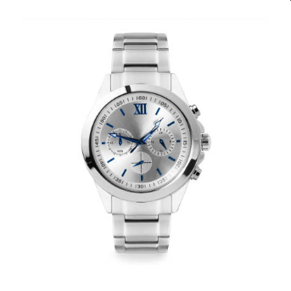

**Product Name:** Silver Wristwatch with Blue Accents

**Description:** This elegant wristwatch features a sleek silver design with a metallic band. The round face showcases a silver dial complemented by blue accents, adding a touch of sophistication. The watch includes three sub-dials for additional functionalities and has a combination of Roman numerals and standard numerals for hour markers. Two buttons on the side provide extra control options.

**Specifications:**

* **Material:** Silver
* **Band Type:** Metallic
* **Dial Color:** Silver with Blue Accents
* **Hour Markers:** Roman numerals and standard numerals
* **Sub-dials:** Three
* **Additional Features:** Two side buttons

**Price**

250$